Web Application

**Internet of Dogs**

Table of contents

Web Application 1

1. Introduction 3

2. Implementation 3

2.1 Technologies 4

2.2 Server Setup 4

2.3 Pages 4

3. Use cases 5

Appendix A 10

1. Running project on local WebSphere application server. 10

## 1. Introduction

The purpose of this report is to describe our project about developing a social media web application using java as the server side language along with various other supporting technologies.

Our web application can be described as a social media event based site for dog owners where they can create event that will take place in real life. The activities are of course supposed to include their dogs, and other members of the site can then choose to join events.

The project went through three phases, we started off with a basic idea and later moved on to writing everything down on paper in the requirement specification. This report deals with the implementation and usage of the application.

## 2. Implementation

After finishing the requirement picture we had a very clear picture on what we were supposed to do and we immediately got to work. All of us had quite a bit of experience in java which was very useful. None of us however had any real experience with the various web technologies such as html, css and javascript.

This lead to a quite slow start since we all felt like we needed to understand the underlying technologies so we practiced on how to write html, css and then how to translate it into jsf. But then the “real” development started to take place and we stopped doing the same thing in practice purpose and instead divided the project into smaller pieces and where each one of us got some responsibilities.

To get us started, one began creating the login page, one setup the needed databases and one investigated and later created the location based users using Google maps API.

When this was done we had a running page with unique users and we were now in a spot where we could start developing the rest of the requirement specification.

This was done by simply having a list of what had to be done and when, prioritizing key components which would be needed for development for other components such as our database access objects and the controllers for the different classes. In almost all cases we started with designing and writing the html and then write the functionality in the backing bean. Because our limited experience with html and css this part was very time consuming so it felt like the smartest way to go to do it this way.

For full work order we refer to our git repository at <https://github.com/dblixt/2DV512>

One thing that has to be mentioned is that we have not implemented the administrator functionality that was mentioned in our requirement specification. This was mainly because of lack of time and also that the functionality itself is not that important in the spectrum of this project so we prioritized other things instead.

### 2.1 Technologies

In the requirement specification we had already specified that we were going to use Java server faces as our server side language. We had also decided that we were going to use the IBM bluemix platform as a service for our application and IBM DB2 as our relational database. For our front end web page we have used css and javascript along with the jsf generated html.

Using DB2 as our database might seem excessive for our small project but the reasoning behind this decision was simply that we were curious of what it had to offer since we had no prior experience of it.

### 2.2 Server Setup

Getting started with jsf on ibm bluemix was a bit tricky. We didn't find any example project with jsf and it took us quite a while to find out which dependencies that were needed to make it run smooth on Bluemix. But we got it working at last.

When we started deploying or application shell to Bluemix we quickly realized that local testing was needed since deployment to Bluemix could take up to two minutes. We tested out Wildfly as a local test server but our project could not work on both Bluemix and Wildfly at the same time since different dependencies were needed.

Later we found IBM Websphere application server which was the same server that was running on IBM Bluemix. It took us a few hours to get it configured and running smoothly but once that was done we were very satisfied with it, see Appendix A.

### 2.3 Pages

#### index.xhtml

This page handles registration of a user as well as login to the website and request of password reset. Ajax is used for a smooth experience.

#### reset.xhtml

Lets users select a new password after a reset has been requested. They get a link to this page from the reset password email.

#### profile.xhtml

This page shows profile information about a specific user.

#### editprofile.xhtml

Lets a user edit his/her own profile information.

#### dog.xhtml

Lets user add or edit information about their dog in profile.

#### event.xhtml

Shows information about a specific event. Lets users request to join the event as well as comment on it if they have joined. If they have already joined they will have the possibility to leave the event.

#### feed.xhtml

Displays a list of all nearby events. The search radius can be set in profile. User can select to view a specific event and will then end up on event.xhtml.

#### notificaitons.xhtml

Displays a list of notifications for a signed in user. There a five different types of notifications these are: event join request, join request approved, event canceled, event updated, comment posted on event.

#### editevent.xhtml

Lets user create a new event or edit an already existing one

## 3. Use cases

Registration/Login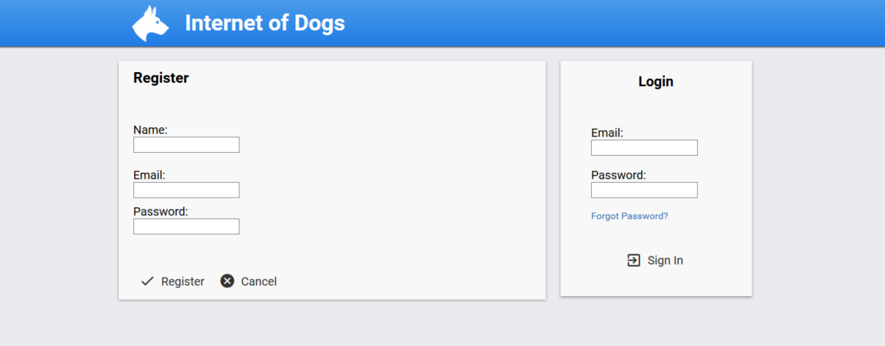

This is the page the user will see when he/she either logins or registers an new account

Profile page

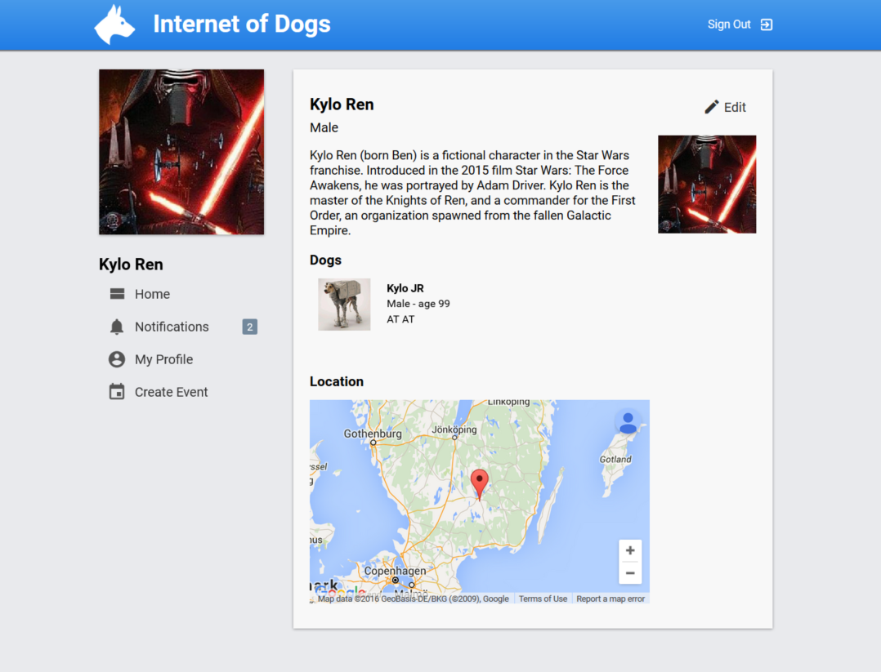

This is the profile page of a user

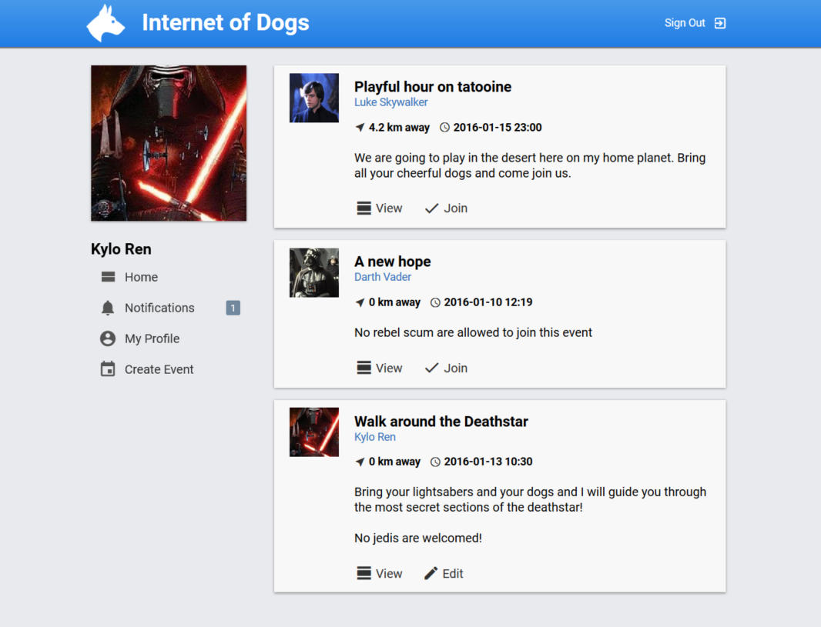Feed

This is the feed.

Event view

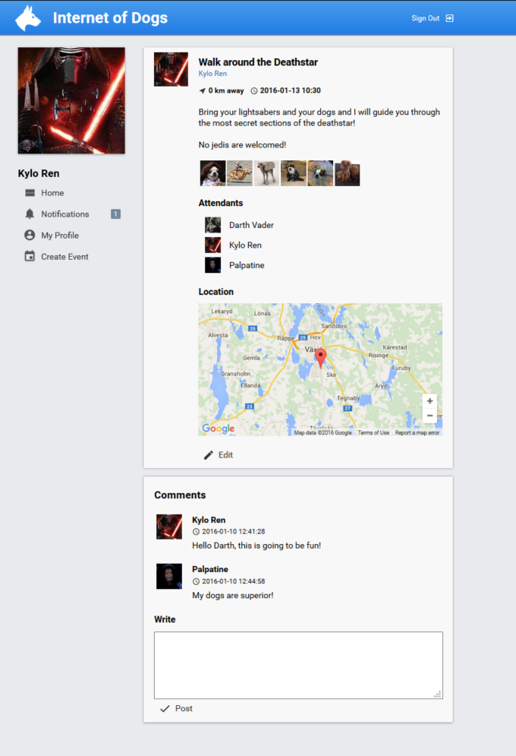

This is the page that is shown when a user views an event.

Create event

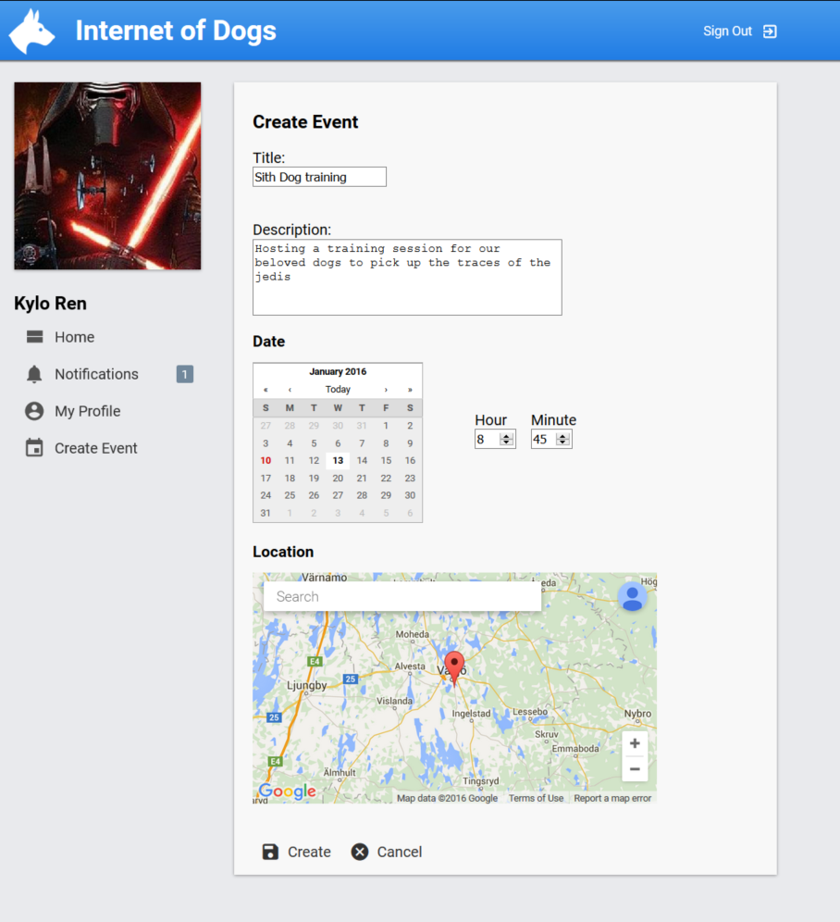

This is the page when a user creates a new event.

Notifications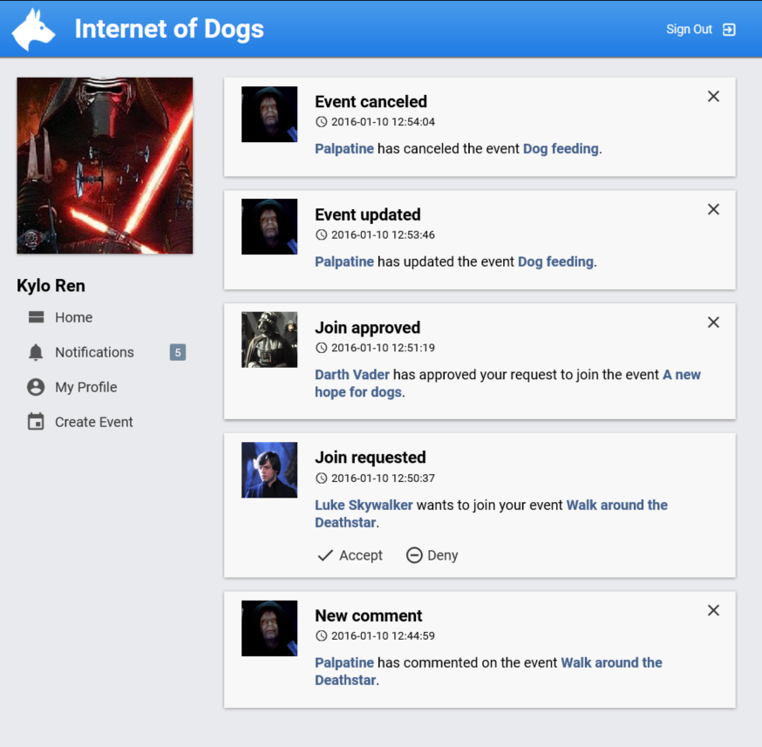

These are the different comments a user can receive.

## Appendix A

### 1. Running project on local WebSphere application server.

Eclipse EE is required for this to work.

1. Install the "IBM Eclipse tools for Bluemix" plugin by going to "Help" -> "Eclipse Marketplace".
2. Select the Server tab in the panel at the bottom, right click and select "New" -> "Server". Select "IBM" -> "WebSphere Application Server Liberty".   
   Write "localhost" in "Servers host name" box. Click next.
3. Select "Install from an archive or repository". Also make sure you have Java 8 JDK configured in eclipse and select to use the JDK. Click next.
4. Click browse to select where you want to install the server. Select "Download and install a new ... " and then select "WAS Liberty V8.5... with Java EE 7 Full Platform". Click next.
5. Search for CouchDB and click install to select that packet too. Click finish, the server will now be downloaded and installed.
6. The server should now be installed. Import our project from github by going to "File" -> "Import" -> "Git" -> "Import from Git". Click next.
7. Select "Clone URI". Click next.
8. Enter "https://github.com/dblixt/2DV512.git". And continue to finish the import.
9. The project will not be able to run on the server yet since the server is not configured, the server.xml has to be edited. The configuration details are located in web_project/websphere_server_config.   
     
   Got to your server installation path, then "usr" -> "servers" -> "defaultServer". Create a directory called "lib" and copy the libraries from the websphere_server_config directory into your newly created one.  
     
   Copy and replace server.xml with the one from the websphere_sever_config directory. You will need to edit it so open it up in your favorite text editor or do it from eclipse.   
     
   What you need to edit is the database connection details. Two databases are used, DB2 and CouchDB. CouchDB is only used for image storage.   
     
   Enter the connection details of your databases and your should be good to go.
10. You should now be able to run the application. The reset password function will however not work since the email account has to be configured. This can be done in the eclipse project in "resources" -> "mailconfig.properties". Create a copy of the "mailconfig_dummy.properties" file and name it "mailconfig.properties". Then enter your gmail account details. Note however that your gmail account need to be enabled for insecure connections.